Disaster Relief & Resource Coordination Platform Using GitOps & ArgoCD
Technical Architecture & Operations Documentation

1. Executive Summary & Project Vision
The Disaster Relief HQ is a production-grade, real-time platform engineered to orchestrate emergency alerts and coordinate life-saving resource distribution during critical crises.
Built on a foundation of modern, secure, and automated infrastructure, the platform adheres strictly to enterprise-level DevOps standards and GitOps philosophies. It guarantees high availability, rapid scaling, and absolute data integrity when seconds matter most.

2. Integrated Architecture Deep Dive
The platform employs a highly secure, distributed microservices architecture hosted on Microsoft Azure. It isolates distinct application concerns using strict network boundaries (Hub-and-Spoke model) and leverages specialized technologies for optimal throughput.

System Overview Diagram
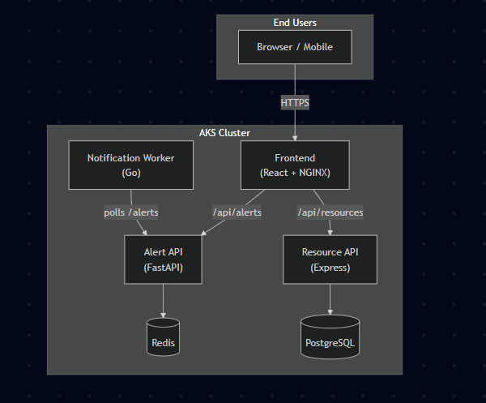

2.1. Compute & Infrastructure
- Kubernetes Engine: Azure Kubernetes Service (AKS).
- Node Pool: Provisioned with Standard_D2s_v3 virtual machines. This specific VM family was selected to optimize compute performance while navigating strict Azure vCPU quota limitations.
- K8s Versioning: Standardized on Kubernetes v1.33.7 to ensure long-term stability and absolute compatibility with Azure's Free/Standard management tiers.

2.2. Application Tiers & Microservices
Service | Language | Port | Connects To | Purpose
frontend | React / NGINX | 80 | alert-api, resource-api (via reverse-proxy) | Public dashboard showing active alerts and resource inventory
alert-api | Python / FastAPI | 8000 | Redis | Ingest and broadcast emergency alerts; caches in Redis
resource-api | Node.js / Express | 3000 | PostgreSQL | Manage relief supply inventories (CRUD)
notification-worker | Go | — | alert-api (HTTP polling) | Background worker simulating SMS/Email dispatch

2.3. Data & Persistence Layer
- Real-time Cache (Redis 7): StatefulSet with a 1 Gi PVC. Acts as a high-speed, in-memory caching layer dedicated to the Alerts API, enabling sub-millisecond data retrieval for active emergencies.
- Relational Database (PostgreSQL 16): StatefulSet with a 5 Gi PVC. The highly reliable persistent storage layer for the Resource API, maintaining the transactional state of inventory. Passwords are managed securely via Kubernetes Secrets.

2.4. Communication Patterns
- Frontend → Backend: NGINX reverse-proxies /api/alerts to alert-api-service:8000 and /api/resources to resource-api-service:3000.
- Alert API → Redis: Direct TCP connection for cache reads/writes.
- Resource API → PostgreSQL: pg pool via postgres-service:5432 with auto-table creation on startup.
- Notification Worker → Alert API: HTTP polling every 10 seconds; deduplicates by alert ID.

2.5. Network Security & Topography
The platform utilizes an isolated Azure Virtual Network (VNet) governed by strict Network Security Groups (NSGs):
- Application Subnet: Permits inbound HTTP traffic from the Azure Load Balancer and allows internal cross-pod communication.
- Database Subnet: Employs a strict "Zero Trust" posture. It is completely isolated, invisible to the public internet, and only accessible via explicitly whitelisted internal IP spaces from the App Subnet.

3. DevOps & Automation Workflow (GitOps)
The deployment lifecycle is governed by a strict GitOps philosophy. The GitHub repository serves as the single source of truth; the state of the Azure infrastructure and application deployments must always match the code repository.

3.1. Infrastructure as Code (IaC)
- Tooling: HashiCorp Terraform.
- Multi-Environment Ready: Full support for dev, qa, uat, and prod environments managed seamlessly via discrete .tfvars variable files.
- Automated Remediation: The Terraform configuration includes coded workarounds for known Azure VM vCPU quota limits and specific provider bugs related to Azure Log Analytics workspace provisioning.

3.2. Code-to-Cloud Pipeline (CI/CD)
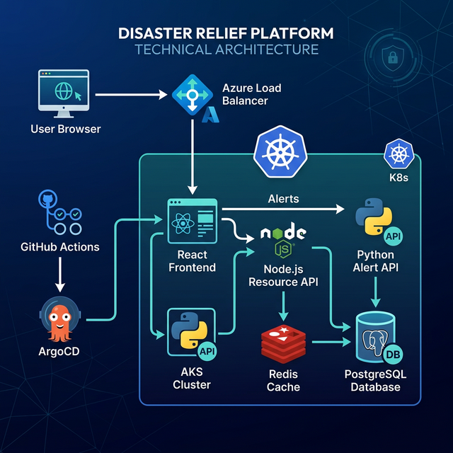

3.3. Key GitOps Principles
- Single source of truth: All Kubernetes configs live in the kube/ directory.
- Declarative: ArgoCD compares desired state (Git) with live state (cluster) and reconciles.
- Automated sync: ArgoCD auto-syncs with prune and selfHeal enabled — no manual kubectl apply needed.
- Image tagging: Each build uses the Git commit SHA as the image tag, ensuring full traceability.

4. Engineering Milestones & Challenges Overcome
During the build phase, the infrastructure team solved several complex, enterprise-grade challenges:
- Quota & Region Optimization: Initial deployments failed due to localized Azure vCPU limits. The team successfully navigated this by relocating the primary cluster to the East US region and optimizing the node selection to the Standard_D2s_v3 family.
- RBAC Hardening: Replaced basic authentication with complex Azure Service Principal roles. Specifically, configured the Role Based Access Control Administrator role to grant AKS secure, least-privilege rights to pull images from ACR.
- Version Stabilization: Prevented deployment drift and incompatible API deprecations by hardcoding and standardizing the AKS control plane and node pools to Kubernetes version 1.33.7.
- Database Security: Designed and implemented a custom "Hub and Spoke" network topography, guaranteeing the PostgreSQL and Redis subnets remain heavily fortified and air-gapped from external routing.
- Complete GitOps Integration: Transitioned from push-based manual deployments to a fully automated, pull-based GitOps architecture using ArgoCD.

5. Disaster Recovery Runbook (Redeployment)
In the event of a catastrophic cluster failure or accidental infrastructure destruction, execute the following Standard Operating Procedure (SOP) to restore the platform from scratch:
- Provision Base Infrastructure: * Navigate to the GitHub Actions tab.
  - Manually trigger the Infrastructure CI/CD workflow. This will run Terraform to rebuild the VNet, Subnets, ACR, and the base AKS cluster.
- Bootstrap ArgoCD:
  - Authenticate locally to the new cluster: az aks get-credentials --resource-group <RG_NAME> --name <CLUSTER_NAME>
  - Install the base ArgoCD manifests:
kubectl create namespace argocd
kubectl apply -n argocd -f [https://raw.githubusercontent.com/argoproj/argo-cd/stable/manifests/install.yaml](https://raw.githubusercontent.com/argoproj/argo-cd/stable/manifests/install.yaml)
- Initiate App Synchronization:
  - Apply the root GitOps application manifest to point ArgoCD at your repository:
kubectl apply -f argocd-app.yaml
  - ArgoCD will now automatically rebuild the Redis, Postgres, React, Python, Node, and Go pods.
- Verify Access:
  - Retrieve the newly generated Azure Load Balancer IP:
kubectl get svc frontend-service
  - Navigate to the provided EXTERNAL-IP in your web browser.

6. Strategic Roadmap & Future Recommendations
To elevate the platform to maturity, the following enhancements are prioritized for upcoming sprints:
- End-to-End Encryption (SSL/TLS): Integrate Azure Application Gateway as an Ingress controller, or deploy cert-manager with Let's Encrypt to enforce strict HTTPS connections for all inbound traffic.
- Elastic Scaling: Implement Horizontal Pod Autoscalers (HPA) for the Python and Node.js API tiers. This will allow the cluster to dynamically provision additional pods based on CPU/Memory spikes during a major crisis event.
- Geographic Redundancy (DR): Configure Azure Site Recovery and multi-region AKS deployments (e.g., Active-Passive between East US and West US) to ensure absolute availability during regional Azure outages.

7. Repository Structure
├── argocd-app.yaml # ArgoCD Application CR
├── src/
│ ├── frontend/ # React + NGINX (Dockerfile)
│ ├── alert-api/ # FastAPI + Redis (Dockerfile)
│ ├── resource-api/ # Express + PostgreSQL (Dockerfile)
│ └── notification-worker/ # Go (Dockerfile)
├── kube/ # All Kubernetes manifests
│ ├── frontend-deployment.yaml
│ ├── alert-api-deployment.yaml
│ ├── resource-api-deployment.yaml
│ ├── notification-worker-deployment.yaml
│ ├── redis-statefulset.yaml
│ └── postgres-statefulset.yaml
├── cicd/.github/workflows/
│ └── main.yml # GitHub Actions CI/CD
├── infrastructure/ # (Existing Terraform — not managed here)
└── docs/
└── architecture.md # Architecture docs

8. Configuration & Secrets
Secret / Config | How Used
postgres-secret | Kubernetes Secret storing POSTGRES_PASSWORD; referenced by both the PostgreSQL StatefulSet and the Resource API Deployment
ACR_NAME | GitHub repo secret consumed by the CI/CD workflow for ACR authentication
AZURE_CREDENTIALS | GitHub repo secret for azure/login Action
REDIS_HOST / REDIS_PORT | Environment variables injected into alert-api pods
ALERT_API_URL | Environment variable injected into notification-worker pods

